**For recent articles from Trends in Ecology and Evolution (i.e., Bjorklund 2019)**

1. Go to <https://www.cell.com/trends/ecology-evolution/home> (or search ‘Trends in Ecology and Evolution’.

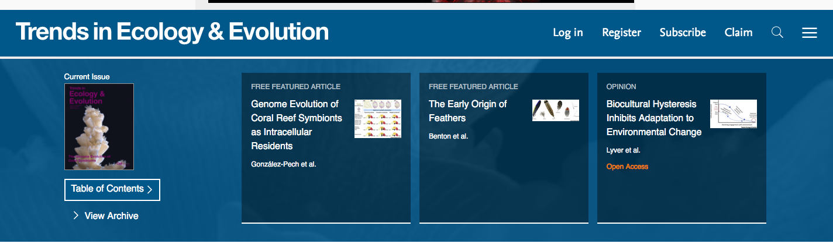

1. There is a magnifying grass on the top right hand side.

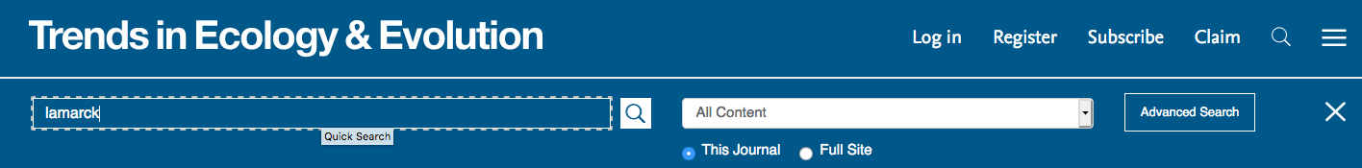

1. The paper we are looking for shows up as the second search result:

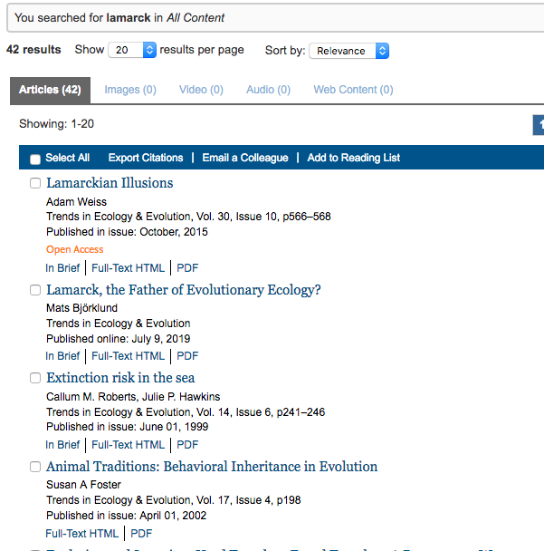

**Using Web of Science**

1. Go to <https://www.library.mun.ca/>
2. Type Web of Science into the search bar.
3. Select “Web of Science core collection”
   1. 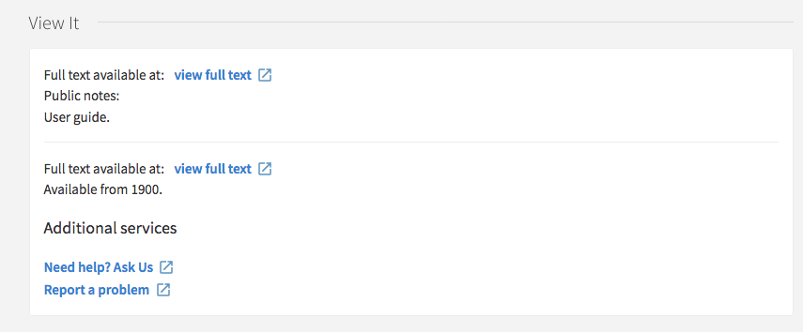
4. Click on “view full text”, but not the one corresponding to the User guide. As shown above the User guide is the first option I have under the view it menu.
   1. 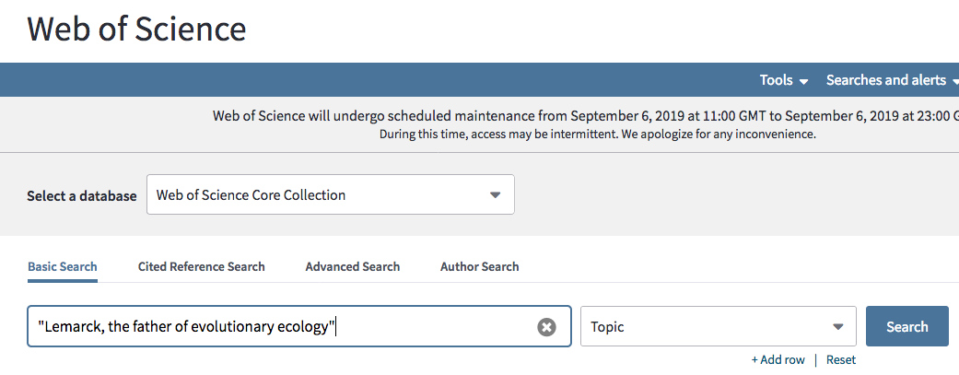
5. I am not able to find this paper using Web of Science because it is very recent and hasn’t yet been indexed.
6. Instead I’ll search for an older paper. A title search for “On r- and K-selection” did not work for me. Instead when I tried:

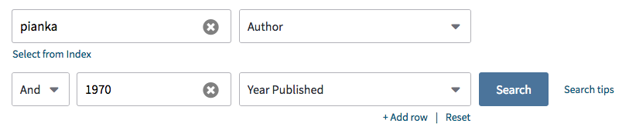

I was finally able to find the paper I was looking for.

